2.45: a) so the speed is 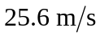.
b) with the minus sign indicating that the balloon has indeed fallen.
c)
d)

